 | PES University, Bengaluru-85  (Established under Karnataka Act No. 16 of 2013) | UE18MA251
MAY 2020: MODEL ESA PAPER, B.TECH, IV-SEMESTER

UE18MA251 – LINEAR ALGEBRA AND ITS APPLICATIONS

 | Time: 03 Hours Answer All Questions Max Marks: 100
1 |  | a) | Do the lines x–4y=1, 2x–y=–3 and –x–3y=4 have a common point of intersection? Explain with a diagram. | 6
 |  | b) | Use Gauss Elimination to solve the following system of equations:  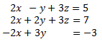 | 7
 |  | c) | Find the inverse of A = 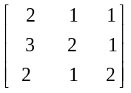using Gauss-Jordan method. | 7
2 |  | a) | Determine whether the given vectors (1, 1, 0), (0,2, 1) in R³ are linearly dependent or linearly independent . | 4
 |  | b) | Check whether the given polynomials 1+2t², 4+t+5t² and 3+2t are linearly dependent. Find the relationship if they are dependent. | 8
 |  | c) | Find PA = LU factorization for the given matrix B. Verify the results.  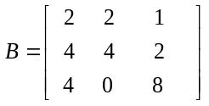 | 8
3 |  | a) | Find the range and the kernel for the given linear transformations  - T(v₁, v₂, v₃) = (v₁, v₂, 0) ii) T(v₁, v₂, v₃) = (v₁, v₂) iii) T(v₁, v₂) = (0, 0) | 6
 |  | b) | Find all vectors in R³ that are orthogonal to (1,1,1), (1, -1,0). Produce an orthonormal basis from these vectors.  A = 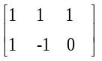 | 8
 |  | c) | Compute the projection matrix onto the line through a₁=(-1, 2, 2) and a₂=(2,2,-1). | 6
4 |  | a) | Use the Gram-Schmidt process to transform the basis 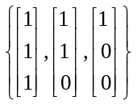.int0 an orthonormal basis for R³. | 12
 |  | b) | Find the largest eigenvalue using power method for the given matrix A. Use (1, 0) as an initial approximation.  A = 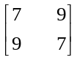 | 8
5 |  | a) | Find the Singular Value Decomposition of  A = 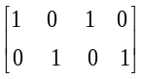 | 14
 |  | b) | Define a positive definite matrix. Check whether the given matrix A is a positive definite or not.  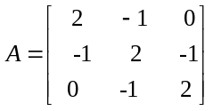.  . | 2+4

